**Q1**. Examine the AI literature to discover whether the following tasks can currently be solved by computers:

* 1. Playing a decent game of table tennis (Ping-Pong).
  2. Driving in the center of Cairo, Egypt.
  3. Driving in Victorville, California.
  4. Buying a week’s worth of groceries at the market.
  5. Buying a week’s worth of groceries on the Web.
  6. Playing a decent game of bridge at a competitive level.
  7. Discovering and proving new mathematical theorems.
  8. Writing an intentionally funny story.
  9. Giving competent legal advice in a specialized area of law.
  10. Translating spoken English into spoken Swedish in real time.
  11. Performing a complex surgical operation.

**Answer:**  
A) Playing a decent game of table tennis (Ping-Pong) – This is solvable by computers. A robot arm can be fitted with a ping pong paddle and motion sensors to move to wherever the ball is.

B) Driving in the center of Cairo, Egypt – This is solvable by computers. Google is working on a self-driving car. It requires a ton of motion sensors in order to respond to its surroundings. One issue would be refilling the gas tank.

C) Driving in Victorville, California -This is solvable by computers. Google is working on a self-driving car. It requires a ton of motion sensors in order to respond to its surroundings. One issue would be refilling the gas tank.

D) Buying a week’s worth of groceries at the market – This would be a challenge for computers right now. The computer would have to know what it (or you) wants, it would have to be able to identify foods without bar codes such as apples.

E) Buying a week’s worth of groceries on the Web – This is solvable by computers. All you need to do is tell your computer what you want, what size (if any), how many, etc. You would also need your payment information accessible to your computer so it can complete the transaction for you. Aside from picking up your groceries, everything is done for you.

F) Playing a decent game of bridge at a competitive level – This is solvable by computers. There are already computers that can play chess at a competitive level, and since bridge isn’t as complicated as chess it shouldn’t be too hard for a computer.

G) Discovering and proving new mathematical theorems – This would be a challenge for computers right now. Computers can solve mathematical theorems, but discovering them is a whole different story. A computer would have to be self aware to discover anything.

H) Writing an intentionally funny story -This would be a challenge for computers right now. Computers don’t know the concept of comedy. You can input jokes into a computer, but it won’t know how to write a funny story with new material.

I) Giving competent legal advice in a specialized area of law – This would be a challenge for computers right now. They would need to know every aspect of the case and that specific area of the law. It’s easier for a computer to give quantitative advice than qualitative advice.

J) Translating spoken English into spoken Swedish in real time – This is solvable by computers.

K) Performing a complex surgical operation – This would be a challenge for computers right now.

Q**2**. Is AI a science, or is it engineering? Or neither or both? Explain.

**Answer:**

Artificial Intelligence is **both a science and engineering**.

Artificial Intelligence (AI) is a branch of research and engineering that integrates science and engineering to construct intelligent machines. It draws on work from philosophy, psychology, and computer science, as well as brain science and languages.

**Q3**. To what extent are the following computer systems instances of artificial intelligence:

**Answer:**

1. **Supermarket bar code scanners:**  
   They are tied into a DB that has info regarding each item in a specific store. The scanner reads the bar code and matches the id of that in the DB and gets the price. Though it requires for the scanner to recognize the barcode correctly there is nothing autonomous that is being done by it. It is just like any other normal peripheral device of a computer.  
   The extent to which the barcode scanner is an instance of an AI system is very thin.
2. **Web search engines:**  
   These search engines retrieve pages using various techniques which might be intelligent. For ex, auto correct feature that uses Data mining based on grasping the user’s corrections of their own spelling errors. It may seems like a very big effort need to be put up by humans, but with the processing powers of computers it is just way too normal task. The intelligence required isn’t high though. Indexing huge amounts of pages to get them in a fraction of a second is a problem in DB design and not Artificial Intelligence.  
   The extent to which web search engine is an instance of an AI system is slightly moderate when compared to Barcode scanner.
3. **Voice-activated telephone menus:**Coming again this is similar to Web search engines. For ex: I say “OK Google” and “Call XYZ”. The software is programmed to recognize the key words like “OK google, Call” etc, and calls the XYZ person by looking up in the directory. If phonebook has multiple entries then it asks us which contact to call. Voice recognition is a part of AI systems but not completely AI. It’s almost predefined. It looks like AI but it’s not. Same is the case with IVR options provided by telephone companies too.  
   The extent to which Voice-activated telephone menus is an instance of an AI system is just moderate, slightly above Web search engines i.e moderate.
4. **Internet routing algorithms that respond dynamically to the state of the network:**Dynamic changes that occur in the network topology require sophisticated algorithms for its detection and rapid optimization, for minimal time and with minimal transmission losses. These are the qualities that a rational agent should possess which is encoporated by Artificial intelligence.  
   The extent to which Dynamic Internet Routing Algorithms is an instance of AI systems is around 85-90%.

**Q4.** Define in your own words:

**Answe:**

1. **Intelligence** is the the ability to solve problems, no matter how miniscule or extraordinary they are. Not only should we be able to solve these problems, but also find improvements to our solutions and continue to expand our knowledge. Being intelligent is one thing, but being able to expand our Intelligence is far more valuable.
2. **Artificial Intelligence** is a piece of machinery, programming, code, etc that was built by humans with the specific task to solve a problem or many problems. But as I’ve stated before, solving problems is one thing, expanding that problem solving knowledge is another. Artificial Intelligence should keep records of its attempts to solve a problem so that it can learn from it’s progress and its mistakes.
3. **Agents** are things that perform actions. They are given instructions and are expected to follow them; but there’s more to it than just following those actions. Agents must also be able to operate on their own, change their actions depending on their surroundings, maintain themselves over an elongated period of time, and develop their own goals to pursue.
4. **Rationality** is doing what is expected of you or what is acceptable to do. When a problem arises there are specific ways that one would solve it; these are filed under Rationality. For example: Your car runs out of gas while driving on the highway and you pull over to solve the problem. A rational action would be to call AAA or a tow service. An irrational action would be to try an siphon gas from a nearby parked police cruiser.
5. **Logical Reasoning** is the ability to perceive a problem logically and know which solution is best to solve it.

**Q5.** List all the fields of AI and explain each one in detail (no more than 8 lines).

**Answer:**

**There are Major Sub-Fields of Artificial Intelligence**

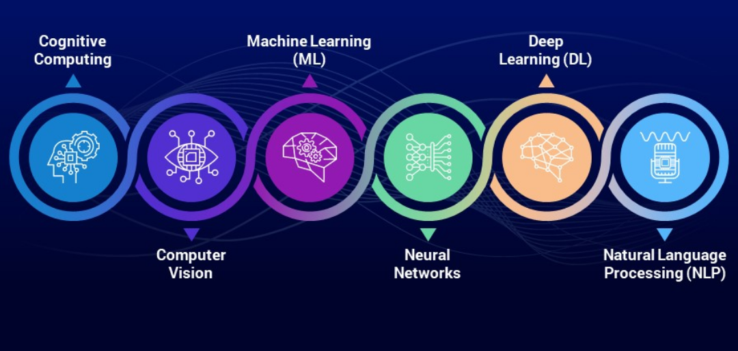

[**Artificial intelligence**](https://en.wikipedia.org/wiki/Artificial_intelligence) (AI) is the field of [**computer science**](https://en.wikipedia.org/wiki/Computer_science) that focuses on developing intelligent computer systems, or systems that display the features we associate with [**intelligence in human**](https://en.wikipedia.org/wiki/Human_intelligence) behaviour, such as [**language**](https://en.wikipedia.org/wiki/Language) comprehension, [**learning**](https://en.wikipedia.org/wiki/Learning), [**reasoning**](https://en.wikipedia.org/wiki/Reason), [**problem solving**](https://en.wikipedia.org/wiki/Problem_solving), etc.

It’s all about **giving machines the ability to mimic human behaviour,** **particularly** [**cognitive**](https://en.wikipedia.org/wiki/Cognition) capabilities. [**Artificial intelligence**](https://rancholabs.com/blog/artificial-intelligence-(ai)-for-kids_7533a), [**machine learning**](https://rancholabs.com/blog/machine-learning-for-kids_87dc3), and [**data science**](https://en.wikipedia.org/wiki/Data_science), are however all interconnected.

**1. Machine Learning**

[**Machine Learning**](https://en.wikipedia.org/wiki/Machine_learning) is **one of the most dynamic fields in advanced technology**, and it creates a lot of hype every time a new product is released by an organization that uses ML techniques and [**algorithms**](https://rancholabs.medium.com/what-is-an-algorithm-75cdcd4296cd) to deliver products to the customer in an innovative manner.

[**Machine Learning**](https://en.wikipedia.org/wiki/Machine_learning) is a **sub-field of**[**artificial intelligence**](https://rancholabs.com/blog/artificial-intelligence-%28ai%29-for-kids_7533a) that is based on the concept that systems/machines can [**learn from data**](https://en.wikipedia.org/wiki/Training,_validation,_and_test_sets#training_set), **[recognise patterns](https://en.wikipedia.org/wiki/Pattern_recognition" \t "_blank)**, and make decisions with little or no human interference.

**2. Neural Network:**

The [**neural network**](https://en.wikipedia.org/wiki/Artificial_neural_network) is a **field of artificial intelligence** that **makes use of**[**neurology**](https://en.wikipedia.org/wiki/Neurology) ( a part of [**biology**](https://en.wikipedia.org/wiki/Biology) that concerns the [**nerve**](https://en.wikipedia.org/wiki/Nerve) and [**nervous system**](https://en.wikipedia.org/wiki/Nervous_system) of the [**human brain**](https://en.wikipedia.org/wiki/Human_brain#:~:text=The%20human%20brain%20is%20the,the%20brainstem%20and%20the%20cerebellum.)). It **incorporates**[**cognitive science**](https://en.wikipedia.org/wiki/Cognitive_science)**into machines**to execute tasks. The **neural network mimics the human brain**, which has an infinite number of neurons, and the neural network’s purpose is to code brain-neurons into a system or computer.

**3. Natural Language Processing**

[**NLP**](https://en.wikipedia.org/wiki/Natural_language_processing) is a **branch of**[**computer science**](https://en.wikipedia.org/wiki/Computer_science)**and**[**artificial intelligence**](https://en.wikipedia.org/wiki/Artificial_intelligence) that allows **computers and humans to communicate using**[**natural language**](https://en.wikipedia.org/wiki/Natural_language). It’s a method of computational analysis of human languages. By mimicking human natural language, it allows a machine to comprehend and interpret data.

NLP is a **method for searching, analysing, comprehending, and extracting information from textual input.** NLP libraries are used by programmers to instruct computers how to extract meaningful information from text input.

# 4. Deep Learning

It is a **process of**[**learning**](https://en.wikipedia.org/wiki/Machine_learning)**in which the machine processes and analyses the input data using a number of ways** until it identifies a single acceptable output. It’s also referred to as **self-learning of machines**. To map the raw sequence of input data to output, the **machine uses a variety of random programmes and algorithms.**

[**Deep learning**](https://en.wikipedia.org/wiki/Deep_learning)would observe all possible human traits and behavioural databases, and it will undergo supervised learning.

**5. Cognitive Computing**

The objective of [**Cognitive Computing**](https://en.wikipedia.org/wiki/Cognitive_computing) is to **initiate and enhance**[**human-machine interaction**](https://en.wikipedia.org/wiki/Human%E2%80%93computer_interaction)**to accomplish complex tasks** and help in problem-solving.

While working with humans on a variety of jobs, machines learn and comprehend human behaviour and feelings in a variety of situations, and then recreate the human thought process in a computer model.

The **machine learns to interpret human language and image reflections** as a result of this practise. Hence, **cognitive thinking combined with artificial intelligence**can create a product with human-like actions and data processing skills.

# 6. Computer Vision

[**Computer vision**](https://en.wikipedia.org/wiki/Computer_vision) is an important component of artificial intelligence because it **enables the computer to identify, analyse, and interpret**[**visual input**](https://en.wikipedia.org/wiki/Digital_image) from real-world pictures and visuals by capturing and intercepting it.

It **uses**[**deep learning**](https://en.wikipedia.org/wiki/Deep_learning)**and**[**pattern recognition**](https://en.wikipedia.org/wiki/Pattern_recognition)**to extract visual information from any data**, including images or video files within PDF documents, Word documents, PowerPoint presentations, XL files, graphs, and photographs, among other formats.